**Screen Layouts**

1. Adding an Item

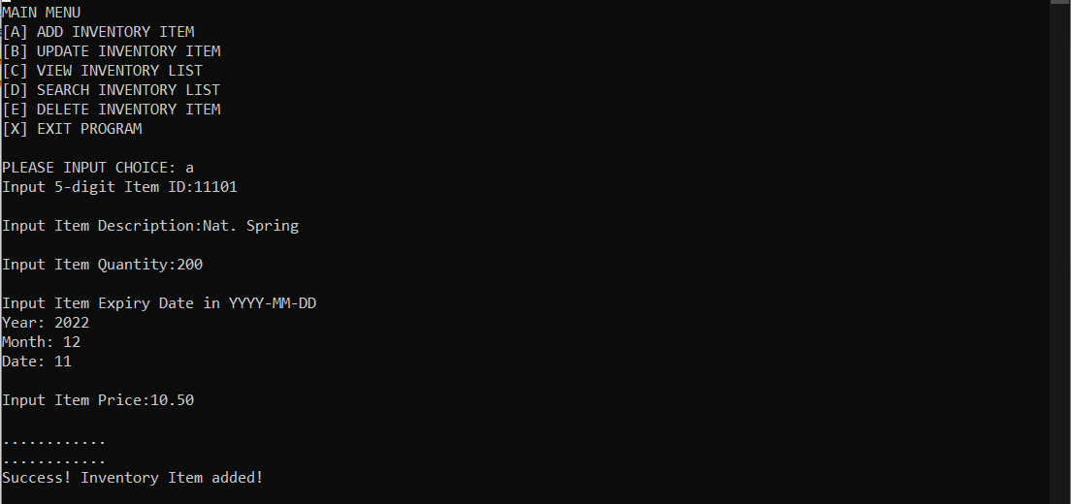

1. Update an Item

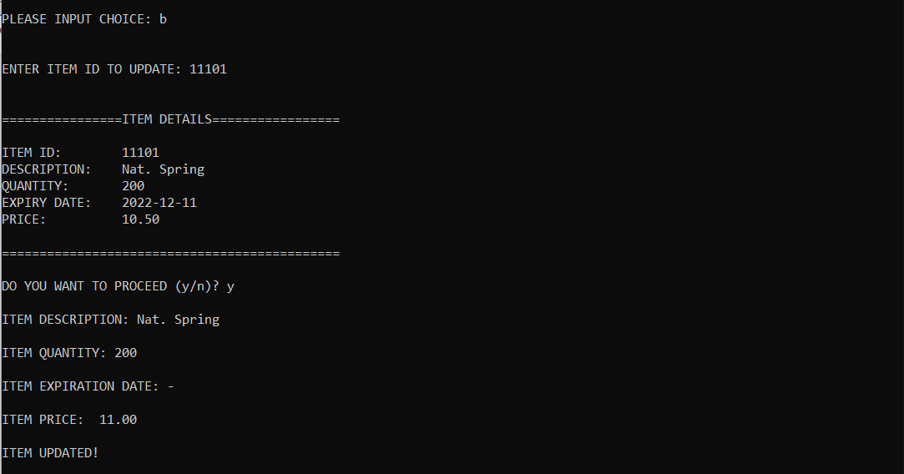

1. View Inventory List

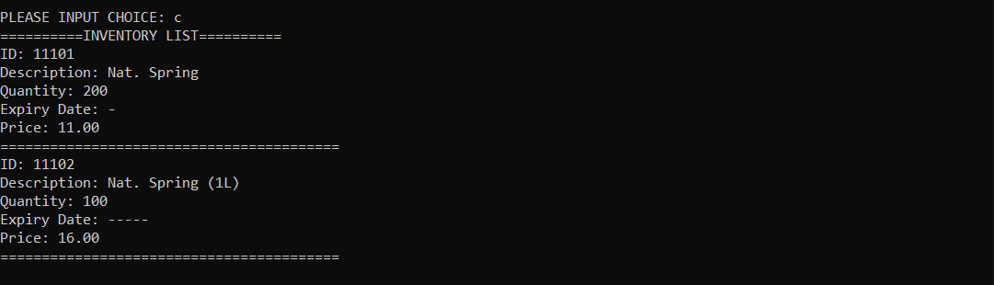

1. Search an Item

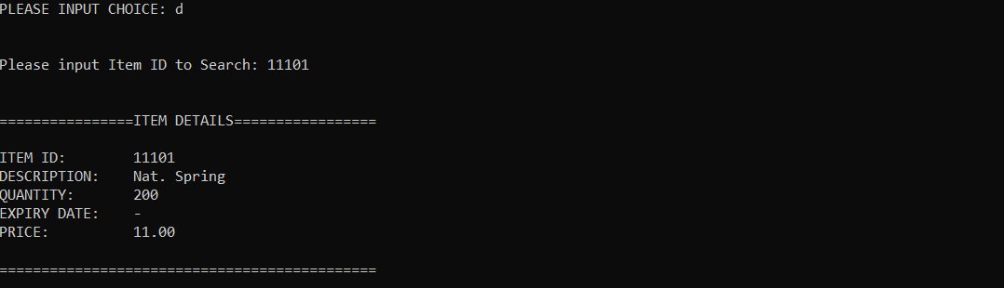

1. Delete an Item

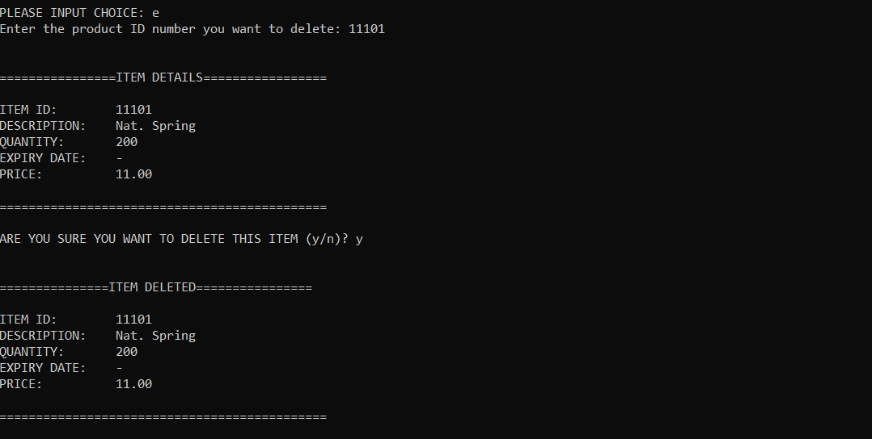

1. Exit the Program

